TEAM NAME:
TEAM MEMBERS:

SDG SELECTED:

PROPOSED NAME:

COMPETITION:

DATE:
CODE BLOODED
Delano D. White 400011585
Deborah McDougall
816046503
Enya Cariah
816050460

SDG 6 – Clean Water and Sanitation

AXIOM D1

UWIRS X ESS ROBOTIC DESIGN
COMPETITION

3/3/2026

Problem Definition and Context:
PROBLEM STATEMENT:
Urban drainage systems across the Caribbean, particularly in Trinidad and Tobago, consist of open concrete channels that often collect plastic waste, organic debris, and algae buildup. These blockages reduce water flow, causing severe flooding during the wet season (June–December) and damaging property. Stagnant water in clogged drains also promotes breeding of the Aedes aegypti mosquito, which spreads dengue, Zika, and chikungunya, posing major public health risks to Caribbean Small Island Developing States.
Maintenance is largely manual, with workers entering drains to remove debris. This exposes them to hazards such as leptospirosis, chemicals, sharp waste, and injury. Cleaning is labor-intensive and typically reactive rather than preventative. A robotics-based solution would reduce human exposure to danger, enable more regular maintenance, and function effectively in shallow drains where heavy equipment cannot operate.
ENGINEERING CONSTRAINTS AND ASSUMPTIONS:
Constraint | Justification
Width ≤ 0.40 m | Must fit within 0.45 m drains with clearance.
Mass ≤ 15 kg | Portable by two people for field deployment.
Water depth 0–15 cm | Designed for shallow, partially blocked drains.
IP67 electronics enclosure | Protects electronics from splashes and temporary immersion (IEC 60529).
Battery-powered (12 V) | No mains access; compatible with common DC motors and LiPo packs.
Prototype cost < $500 USD | Meets student budget using COTS components
Wireless range ≥ 50 m | Allows above-ground operation via 2.4 GHz WiFi.
Emergency stop | Hardware and software E-stop for immediate shutdown.
Assumptions: (1) Drains are open-top concrete channels with vehicle or pedestrian access nearby for deployment. (2) Debris consists primarily of plastic waste and organic matter < 2 kg per item. (3) Ambient temperature 25–35 °C (tropical climate; no cold-weather considerations).
MEASURABLE GOALS:
Metric | Target
Debris collection rate | ≥ 0.5 kg per 100 m pass
Algae removal coverage | ≥ 80% of contacted surface
Operating speed (in drain) | 0.10 – 0.20 m/s
Continuous battery life | ≥ 60 minutes
Drain length per charge | ≥ 400 m
Max. operating water depth | 15 cm
Deployment time (unpack to run) | ≤ 5 minutes

Conceptual Robotics Approach
ROBOT/PLATFORM SELECTION AND JUSTIFICATION
AXIOM D1 is a compact, tracked amphibious robot designed specifically for shallow-drain maintenance. A tracked (caterpillar) platform was selected over wheeled or legged alternatives for the following engineering reasons:
(a) Traction - Rubber tracks provide continuous ground contact across wet, silt-covered, and algae-slippery drain floors where wheels would lose grip [5].
(b) Obstacle traversal - Tracks can climb over small debris accumulations and raised drain joints (up to ~5 cm) without becoming stuck.
(c) Load distribution - The wider contact patch prevents the robot from sinking into soft sediment layers that accumulate in unmaintained drains.
(d) Amphibious operation - Rubber tracks function in both dry and shallow-water conditions without modification, unlike wheel-based systems that require separate waterproofing for hub bearings.
(e) Differential steering - Two independently driven tracks enable zero-radius turning, critical for maneuvering within the confined width of drainage channels.
The platform integrates three functional mechanisms:
• Front-mounted scoop and conveyor belt for solid waste collection
• Side-mounted rotating nylon brush assemblies for algae scrubbing
• Onboard sealed collection bin (~5 L) with mesh drainage
This combination addresses both primary drain maintenance tasks, debris removal and biofilm cleaning in a single pass, inspired by amphibious garbage-collection robot designs in the literature [6].
SYSTEM ARCHITECTURE
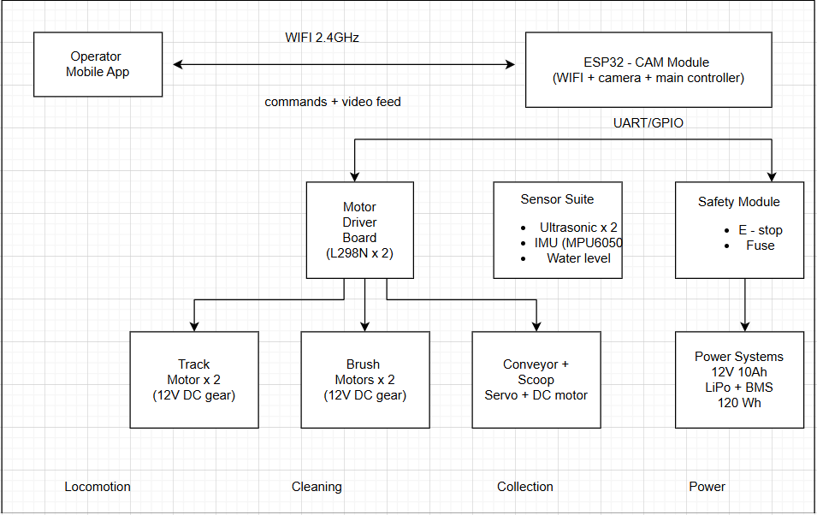
1. Locomotion - Two 12 V DC gear motors (each ~3 A under load) drive rubber caterpillar tracks via sprocket-and-chain. Differential speed control enables steering.
2. Collection - A front-mounted scoop (servo-actuated tilt) feeds debris onto a short conveyor belt (small DC motor) that deposits waste into a sealed 5 L collection bin with mesh drain holes.
3. Cleaning - Two rotating nylon brush assemblies (12 V DC, ~1 A each) on adjustable mounts scrub algae from drain floor and walls.
4. Sensing - Two ultrasonic sensors (HC-SR04) for forward and rear obstacle detection; MPU6050 IMU for tilt/orientation; resistive water-level sensor to monitor depth.
5. Control - ESP32-CAM serves as main controller, handling WiFi communication, live video streaming, and GPIO control of motor drivers.
6. Communication - 2.4 GHz WiFi link to a mobile app providing live camera feed and directional controls; range ~50 m line-of-sight.
7. Power - 12 V, 10 Ah LiPo battery pack with battery management system (BMS) and 15 A fuse protection; total capacity 120 Wh.
FEASIBILITY
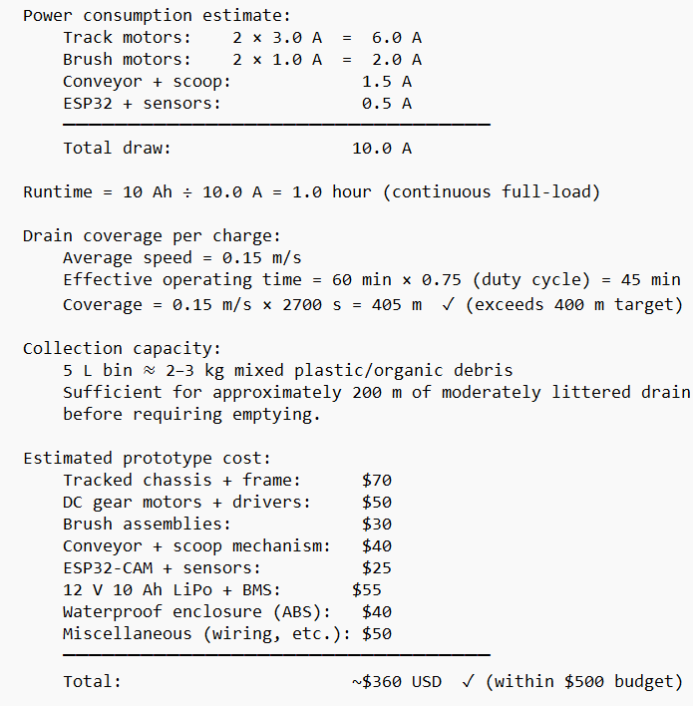
Sustainability and SDG alignment
SDG REVELANCE
AXIOM D1 supports UN SDG 6 (Clean Water and Sanitation), Target 6.3 by reducing pollution in urban waterways. In Trinidad and Tobago, drains are major pathways for solid waste entering rivers and coastal waters. By removing debris and algae before they reach downstream ecosystems, the robot lowers pollutant loads and also advances SDG 11.5 by restoring drain capacity and reducing urban flood risk.
Environmental impact: Each deployment removes several kilograms of waste, limits eutrophication in downstream waters, operates with zero direct emissions, and at municipal scale could intercept significant monthly waste before it reaches the ocean.
Social impact: The system reduces worker exposure to contaminated water, supports proactive flood prevention (protecting vulnerable communities), and remains affordable and scalable due to low cost, widely available components, and minimal training requirements.
SUMMARY:
AXIOM D1 is a compact amphibious robot that navigates shallow drains to remove solid waste and scrub algae. Supporting SDG 6 (Clean Water and Sanitation), it reduces water pollution and flood risk while replacing hazardous manual cleaning with a low-cost, scalable solution for Small Island Developing States.
REFRENCES
[1] Government of the Republic of Trinidad and Tobago, Ministry of Works and Transport, "Drainage Division Maintenance of Watercourses," available at: https://www.mowt.gov.tt.
[2] K. Mycoo, "The Caribbean and Climate Change: Vulnerability, Adaptation, and the Role of Urban Planning," J. Urban Plan. Dev.,vol. 144, no. 4, 2018.
[3] Pan American Health Organization (PAHO), "Dengue in the Caribbean: Epidemiological Trends and Vector Control Strategies," PAHO/WHO Report, 2023.
[4] R. Ganoza et al., "Determining risk for severe leptospirosis by molecular analysis of environmental surface waters for pathogenic Leptospira," PLoS Med., vol. 3, no. 8, e308, 2006.
[5] R. Siegwart, I. R. Nourbakhsh, and D. Scaramuzza, Introduction to Autonomous Mobile Robots, 2nd ed. Cambridge, MA: MIT Press, 2011.
[6] Y. Zhang, Z. Huang, C. Chen, X. Wu, S. Xie, H. Zhou, Y. Gou, and M. Ma, "A Spiral-Propulsion Amphibious Intelligent Robot for Land Garbage Cleaning and Sea Garbage Cleaning," J. Mar. Sci. Eng., vol. 11, no. 8, 1482, 2023. doi: 10.3390/jmse11081482.
[7] United Nations, "Sustainable Development Goal 6: Clean Water and Sanitation — Targets and Indicators," Department of Economic and Social Affairs, 2015. Available: https://sdgs.un.org/goals/goal6.

Appendix
DETAILED COMPONENT LIST
Component | Specification | Est. Cost (USD)
Tracked chassis (aluminium) | 400 × 300 × 100 mm | $70
DC gear motors ×2 | 12 V, 200 RPM, 5 Nm | $30
L298N motor driver ×2 | Dual H-bridge, 2 A/channel | $20
Nylon brush motor ×2 | 12 V DC, 3000 RPM | $20
Brush heads (nylon) | 60 mm diameter, replaceable | $10
Conveyor belt motor ×1 | 12 V DC, 100 RPM | $15
Scoop servo ×1 | MG996R, 10 kg·cm | $10
Conveyor belt (rubber) | 200 × 80 mm loop | $15
ESP32-CAM module | WiFi + 2MP OV2640 | $10
HC-SR04 ultrasonic ×2 | Range: 2–400 cm | $5
MPU6050 IMU | 6-axis accelerometer/gyroscope | $5
Water level sensor | Resistive, analog | $3
LiPo battery 12V 10 Ah | 3S2P, with BMS | $55
ABS waterproof enclosure | IP67, 200 × 150 × 80 mm | $40
Wiring, connectors, misc. | — | $25
3D-printed brackets/mounts | PLA/PETG filament | $25
TOTAL |  | ~$358

